ARTIST PACKET
LIVING ART MUSEUM CHECKLIST Partners: _______________________________________

- Decide your artist and the artist’s artwork – Who will be who? (Each role is the same amount of research and work )

Artist: _________________________________________ Partner: ___________________________________
Artwork: _______________________________________ Partner: ___________________________________

- Research at least 10 facts about YOUR role (artist researches artist, artwork researches artwork)
  - Fill out YOUR fact page in YOUR packet

- Sketching: Sketch your costume if you are the artist – brainstorm these ideas together
  - Fill out the costume sketch page in the artist packet

- Make pieces of and bring in costume

- Begin the artwork together.
  - If you are painting:
    - Use grid system
    - Draw with pencil (don’t forget to draw where your head will go!)
    - Begin to paint

- Write YOUR speech (your facts in full sentences) – You will be speaking in “I” – “I painted the Mona Lisa…”, “I am the self-portrait of Vincent van Gogh”

- Make “talking” button

- Practice, Practice, Practice, Practice, Practice

- Present in Class – Date: _______________________

- Fill out Rubric

ARTIST INFO (You need at least 10 facts!)
Artist: ____________________________________ Partner playing Artist: ___________________________
Date of Birth (and Death):
Place of Birth:
Art Movement or Style:
Famous art works?
Why is this artist famous?
Something unusual about this artist?
Other facts:
ARTIST COSTUME PLAN
-Find an image of your artist and sketch the props you would need in order to most look like this artist.
-You will use at least 5 props.
-Label (write what it is), draw, and color each prop clearly

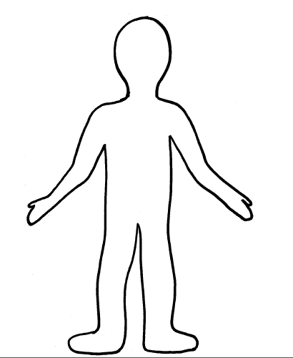

LIVING ART MUSEUM RUBRIC Partners: _______________________________________

Artist: _________________________________________ Artwork: _______________________________________
Objectives | Great! We rocked this! | We did okay – would change things next time | Could have done better
TEAMWORK
We used our time wisely | 2 | 1 | 0
We solved problems in a fair and caring way | 2 | 1 | 0
We both participated and did our best | 2 | 1 | 0
Our project packet is completed | 2 | 1 | 0
PREPARATION
We found 10 facts about EACH of our parts | 2 | 1 | 0
We planned and brought in the props for the costume | 2 | 1 | 0
We gridded the artwork | 2 | 1 | 0
We painted the artwork together | 2 | 1 | 0
We both made talking buttons | 2 | 1 | 0
PRESENTATION
Our speeches were well planned and practiced | 2 | 1 | 0
You could clearly hear us | 2 | 1 | 0
We spoke in first person | 2 | 1 | 0
One of us was in full costume | 2 | 1 | 0
One of us was dressed as the artwork | 2 | 1 | 0
We presented in class | 2 | 1 | 0

Comments: Total: _____________ /30 points

